Module Code: PUSL 3120
Module: Full Stack Development



Assignment 02: Working REST APIs Integrated with Frontend
Project Report

NovaSync

Group 59

Chapter 01. Introduction
NovaSync is a full-stack collaborative task management application designed to help teams organize, monitor, and manage project tasks through a centralized web platform. The application combines a React-based frontend with a Node.js and Express backend to provide a structured client-server architecture. The frontend provides the main user interface for managing tasks, viewing the project board, monitoring progress, managing team members, and communicating with other team members. The backend provides REST API services that handle communication between the client application and the server.
For Assignment 02, the static frontend developed during the previous stage was extended by introducing a working backend and REST API layer. Mock data is used to demonstrate API functionality, and the frontend has been connected to the backend services so that application operations can be handled through API requests rather than relying only on the static interface.
The main features demonstrated in this stage include:
- User login and authentication
- Task creation and management
- Task retrieval and updating
- Task deletion
- Kanban-style board management
- Team member management
- Dashboard and project information
- Messaging functionality
- Frontend and backend communication through REST APIs
The project follows a progressive full-stack development approach in which the React client is extended with backend services before the later database, real-time, testing, and deployment stages.
1.2 Objectives
- To develop a Node.js and Express backend for NovaSync.
- To implement working REST API endpoints using mock data.
- To integrate the REST APIs with the React frontend.
- To support CRUD operations for application data.
- To establish communication between the client and server.
- To provide authentication-related backend functionality.
- To maintain a clear separation between frontend and backend responsibilities.
- To prepare the application for later MongoDB and full-stack integration.

Chapter 02. Team Roles and Contributions
The development of Assignment 02 required active contributions across both the client and server environments. The responsibilities of each team member are detailed below:
01. Member: Sathira Lakshan – 31900
UI/UX & Styling Lead [Frontend] – Designed and maintained the user interface, visual styling, layouts, and overall design consistency of NovaSync, updating UI states to handle asynchronous API loading.
02. Member: LDP Kavindya – 30890
Drag & Drop Logic [Frontend] – Implemented the task drag-and-drop interactions and ensured tasks could be moved between the Kanban workflow columns, triggering backend PUT requests.
03. Member: PGDT Panagoda – 33654
React State & Data Link [Frontend] – Managed React application state and integrated frontend components with backend API data using Axios and the Context API.
04. Member: GMA Mihiranga – 34019
MongoDB Data Structuring [Database] – Managed the existing client-side persistence structure and prepared the application's mock data schemas for the future transition to MongoDB.
05. Member: EMMN Edirisinghe – 33818
Real-Time WebSync [WebSockets] – Developed the real-time communication structure using Socket.IO, laying the groundwork for synchronized updates between connected users.
06. Member: RMSD Rathnayaka – 33774
API Routes & Logic [Backend] – Implemented REST API routes and Express controller logic for operations such as retrieving, creating, updating, and deleting application data.
07. Member: RHLS Dayananda – 37426
Node/Express Server [Backend] – Developed the primary Express server structure, middleware, CORS configuration, and backend foundation required to serve the application APIs.
08. Member: MADT Gimhani – 36499
User Login & Auth [Backend] – Developed the authentication functionality, protecting backend access through the application's authentication middleware routines.
09. Member: BSB Abeysooriya – 33581
Unit & Integration Tests [QA/Testing] – Worked on testing the frontend and backend functionality using Postman, verifying that all API operations behave and return expected HTTP status codes.
10. Member: KGSN Bandara – 34375
Docker & GitHub [DevOps] – Managed the GitHub repository, handled project collaboration and version control across the frontend and backend directories, and prepared deployment configurations.

Chapter 03. Technologies Used
3.1 React
React is used for the client-side application and provides the component-based frontend interface.
3.2 Vite
Vite is used as the development and build tool for the React frontend.
3.3 JavaScript / JSX
JavaScript and JSX are used to implement the frontend components, application logic, and user interactions.
3.4 Node.js
Node.js provides the runtime environment for the backend application.
3.5 Express.js
Express.js is used to create the backend server and REST API endpoints.
3.6 REST API
REST APIs provide communication between the React frontend and the backend server. The APIs support operations required by the NovaTrack application, including task and authentication-related operations.
3.7 Axios
Axios is used on the frontend to communicate with backend API endpoints.
3.8 Authentication Middleware
The backend contains authentication middleware to process authenticated requests and protect restricted API operations.
3.9 Mock Data
Mock data is used during this milestone to provide test data for the working REST API before the complete MongoDB persistence layer is introduced.
3.10 Socket.IO
The project also includes Socket.IO client/server-related functionality for the real-time communication layer that supports the application's collaborative messaging and future synchronized updates.

Chapter 04. GitHub Repository and Assignment Tag
4.1 GitHub Repository Link: https://github.com/ZeroTrace0245/Full-Stack-Development
4.3 Assessment 2 Tag: Assignment 02 - Working REST APIs (with mock data) Integrated with Frontend)
4.3 Direct README File Link: NovaSync README File

Chapter 05. API Collocations
The REST API was tested using Postman. The collection demonstrates communication between the client and server and verifies the main API operations.
The backend project contains separate route modules for:
- Authentication
- Tasks
- Messages
These routes are handled by the Express server and are accessed by the frontend through HTTP requests.
5.1 Authentication API
The authentication API handles user login and authentication-related requests.
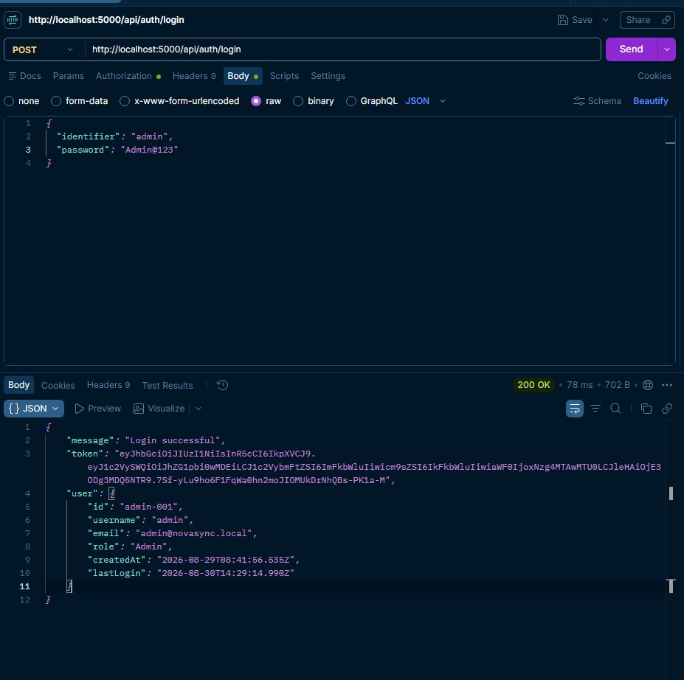
Figure 5.1: Authentication API in Postman
5.2 Tasks API
The Tasks API manages task-related operations.
The API supports operations such as:
- Retrieving tasks
- Creating tasks
- Updating tasks
- Deleting tasks

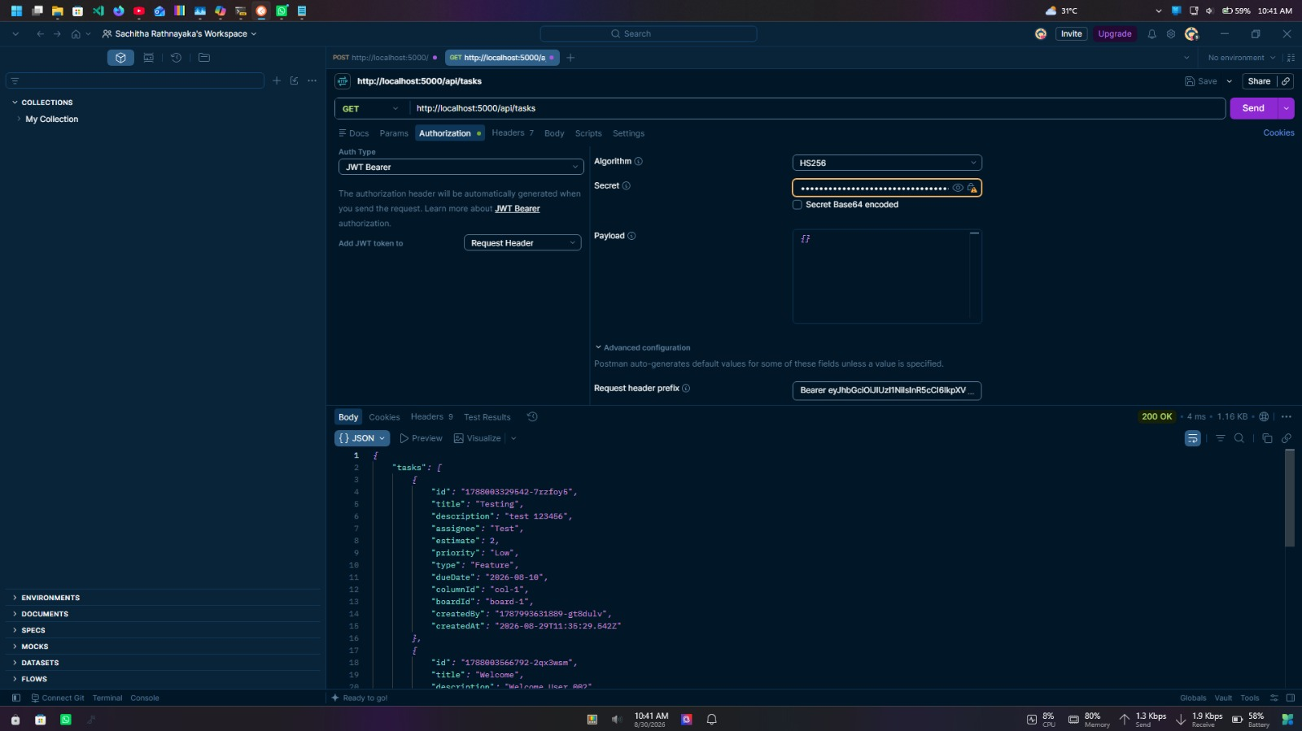
Figure 5.2.1: Tasks API – GET/RETRIEVE Request

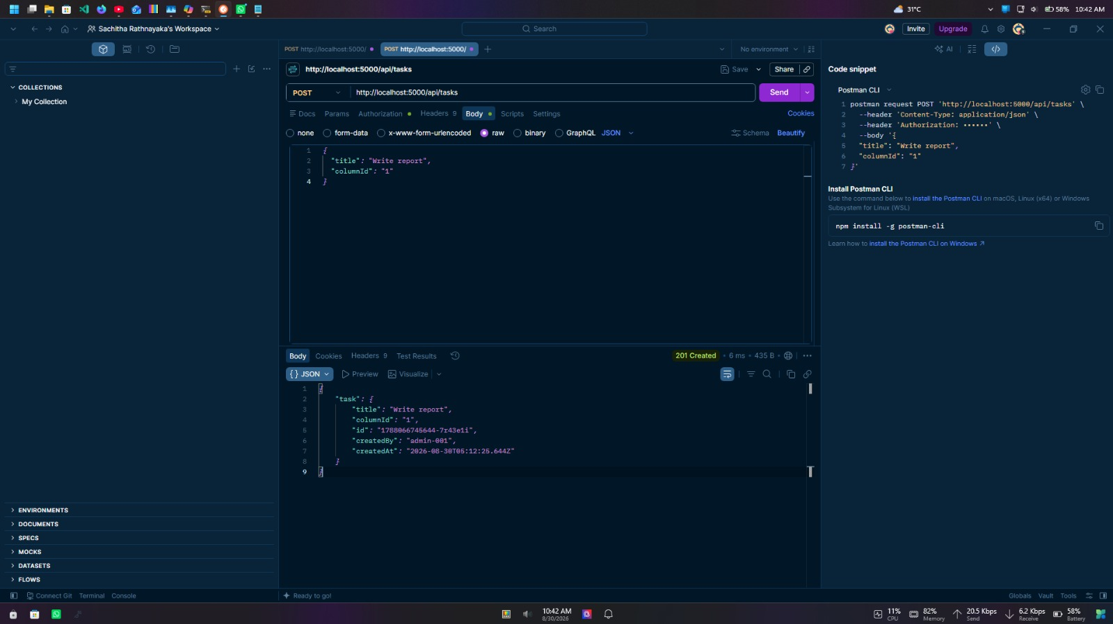
Figure 5.2.2: Tasks API – POST/CREATE Request

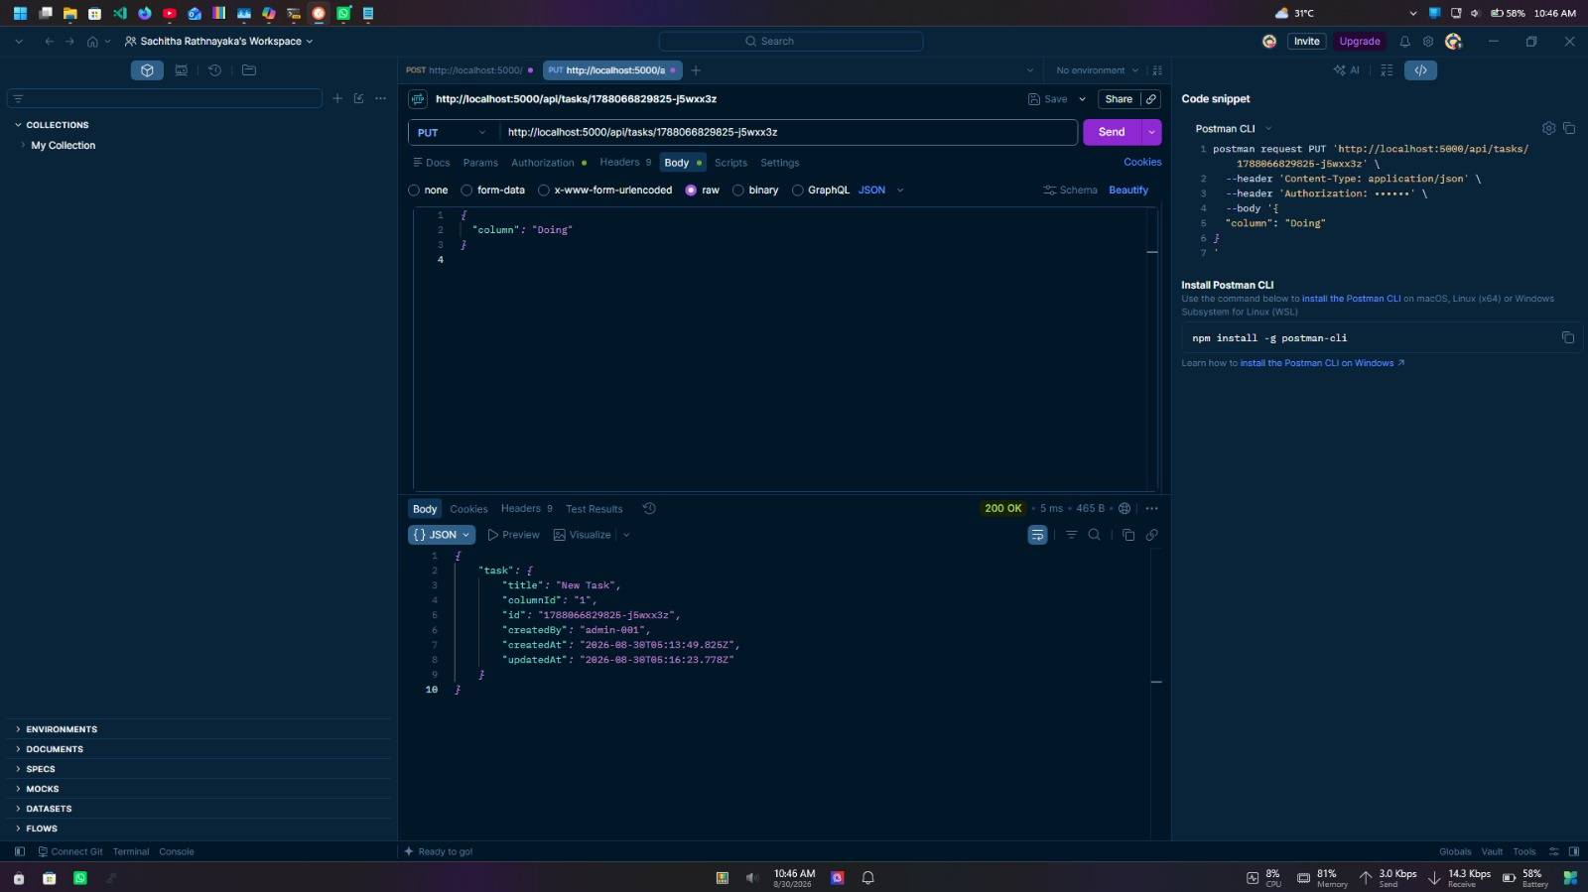
Figure 5.2.3: Tasks API – Update Request

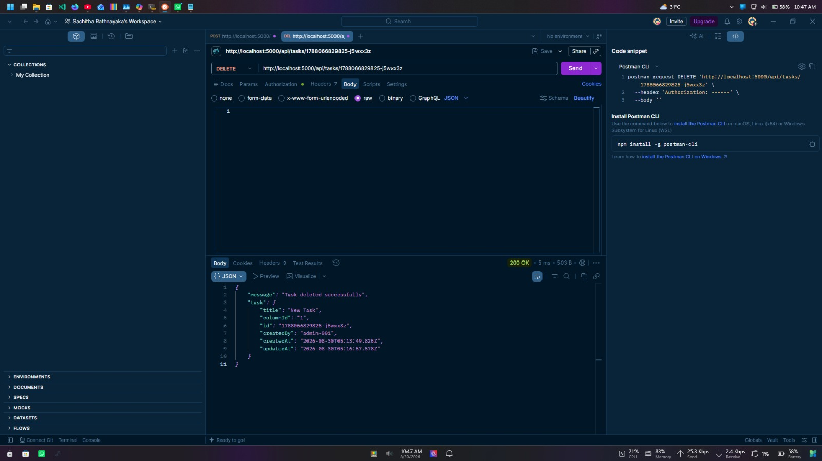
Figure 5.2.4: Tasks API – DELETE Request
5.3 Messages API
The Messages API supports message-related communication for the application's collaborative messaging functionality.
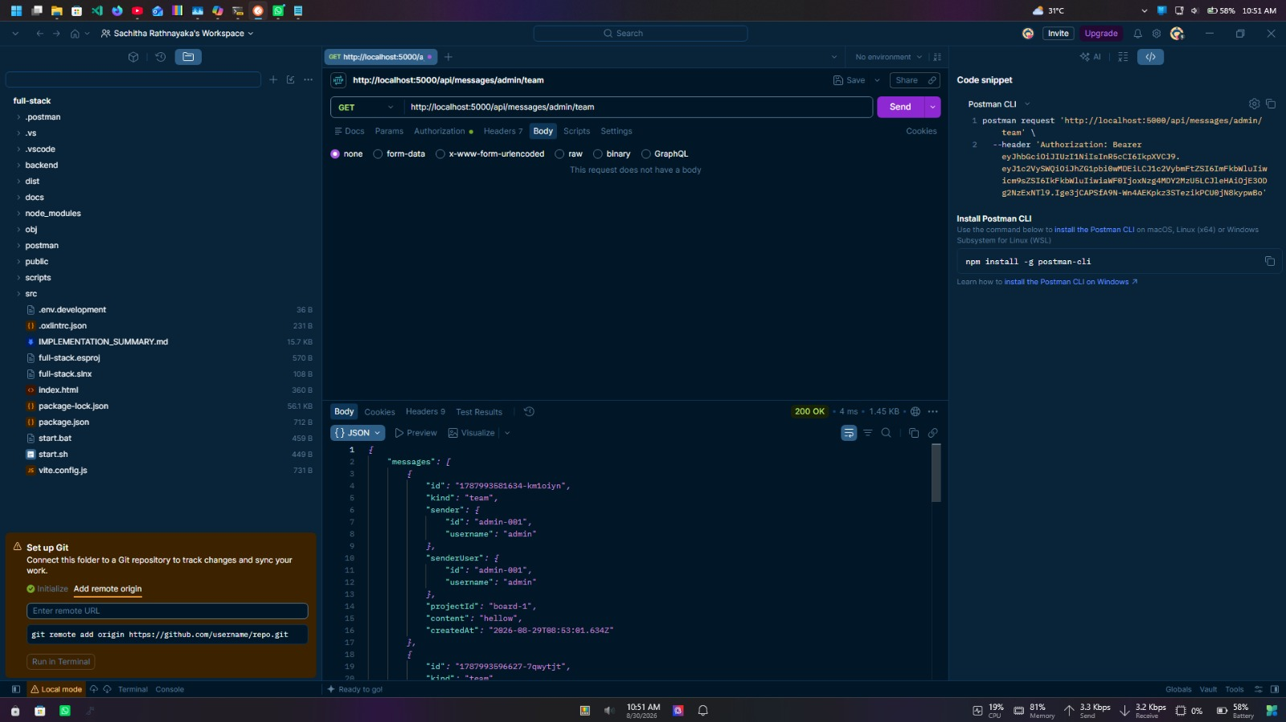
Figure 5.3: Messages API in Postman

Chapter 06. Frond-End Screenshots

6.1 Login Page
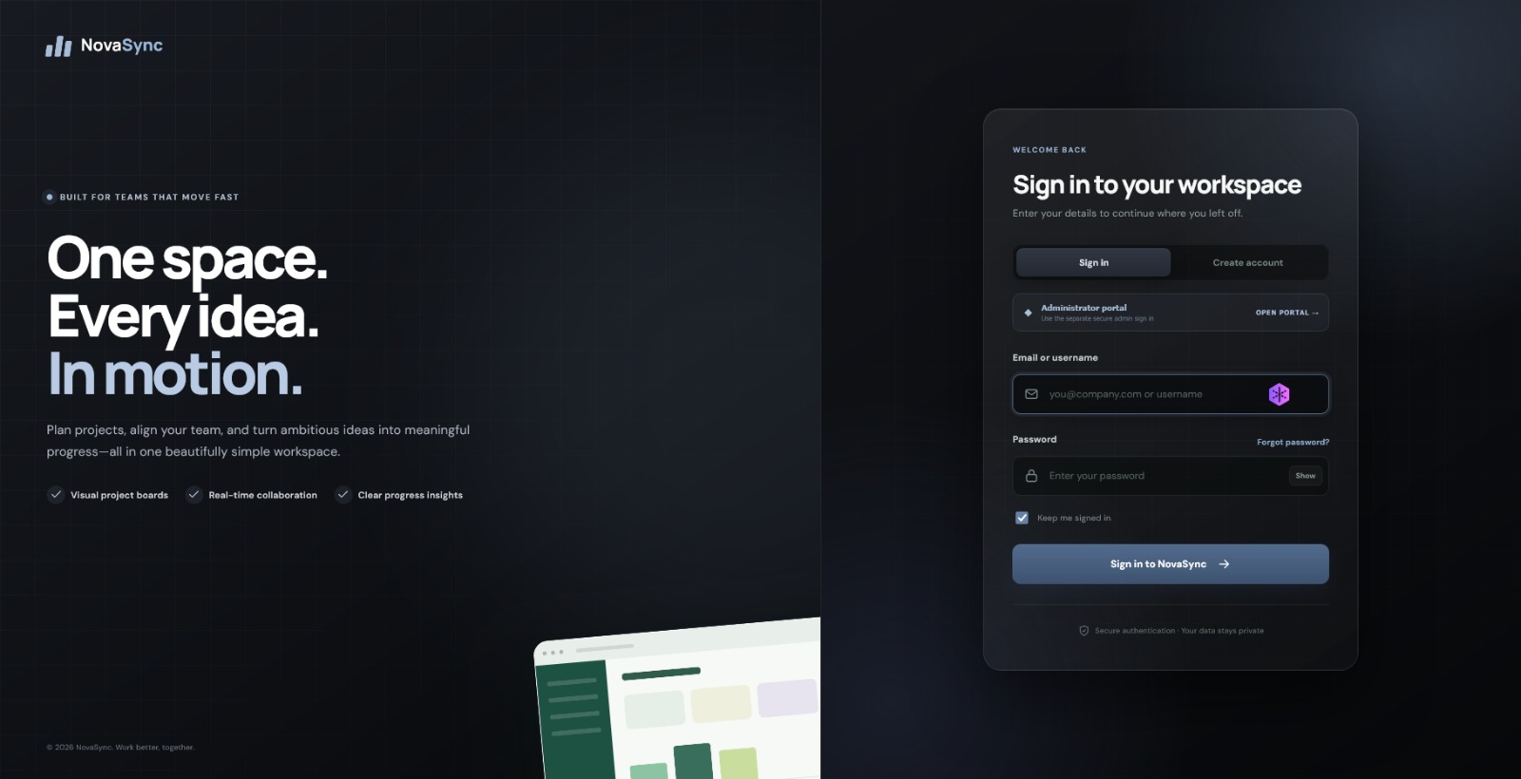
Figure 6.1: NovaSync – Login Page
6.2 Dashboard
The Dashboard provides an overview of project activity and task progress through key statistics and project information.
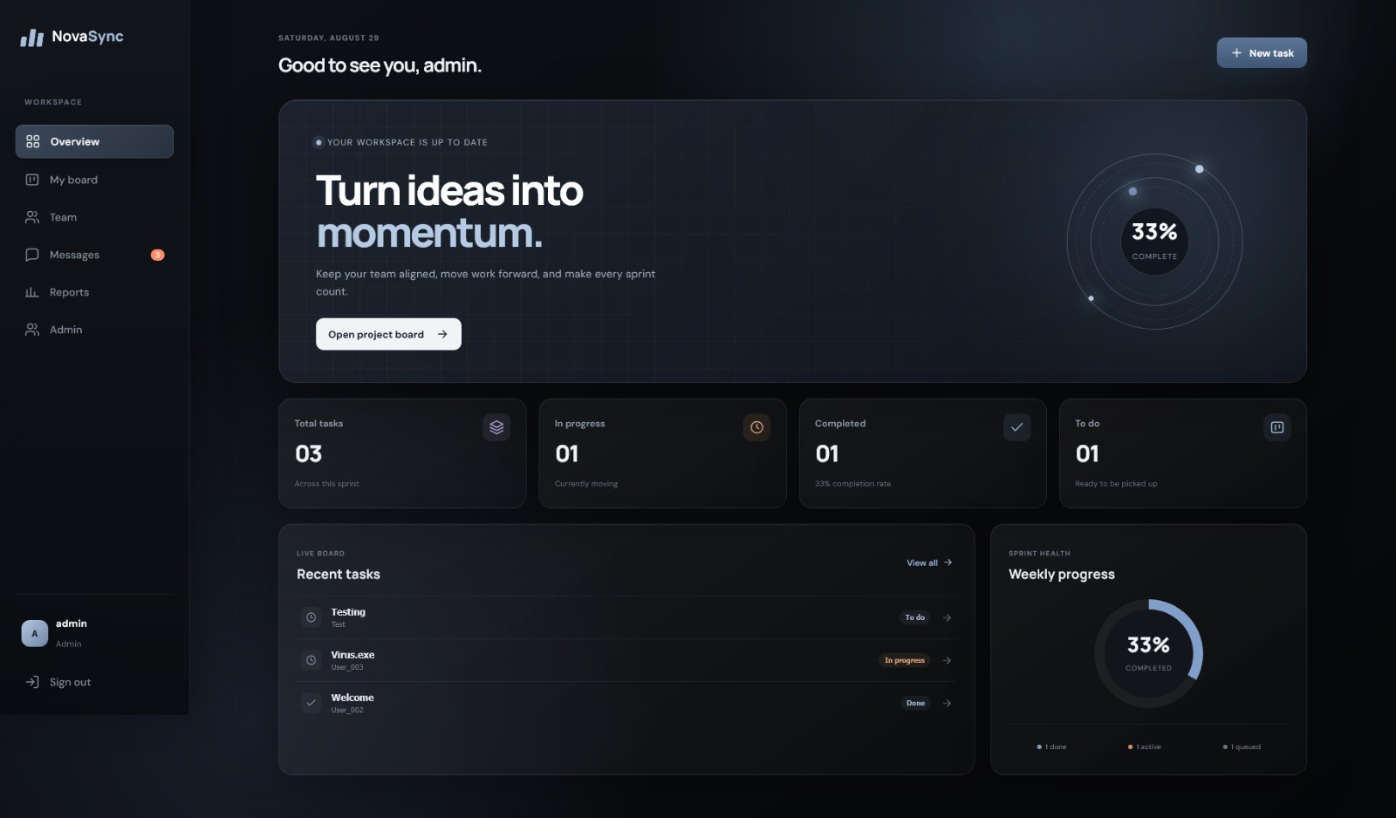
Figure 6.2: NovaSync – Dashboard
6.3 Sprint/Task Board
The Sprint Board is the main task-management interface of NovaSync. Tasks are organized according to their current workflow status and can be managed through the application.
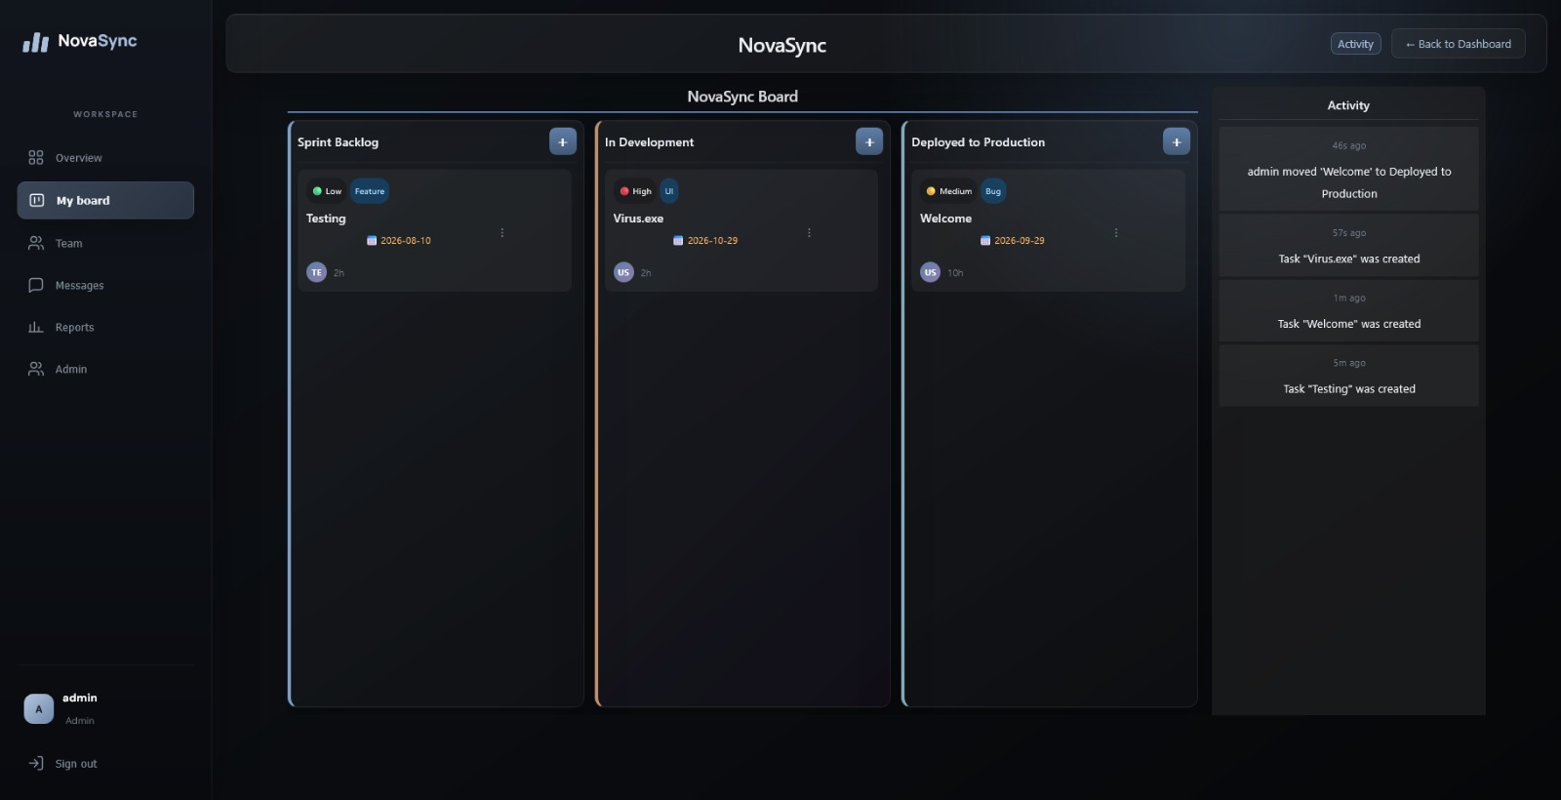
Figure 6.3: NovaSync – Sprint/Task Board
6.4 Team Members
The Team Members page displays the users associated with the NovaSync project.
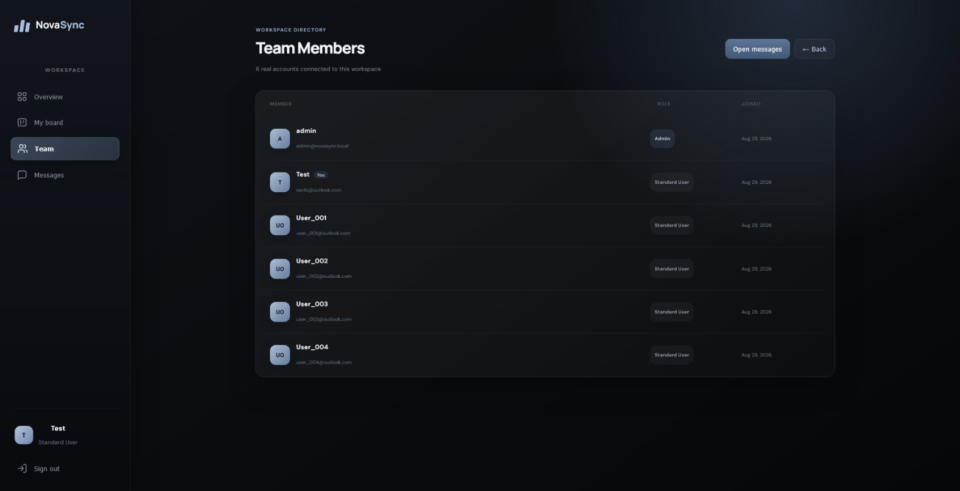
Figure 6.4: NovaSync – Team Members
6.5 Create Task
The Team Members page displays the users associated with the NovaSync project.
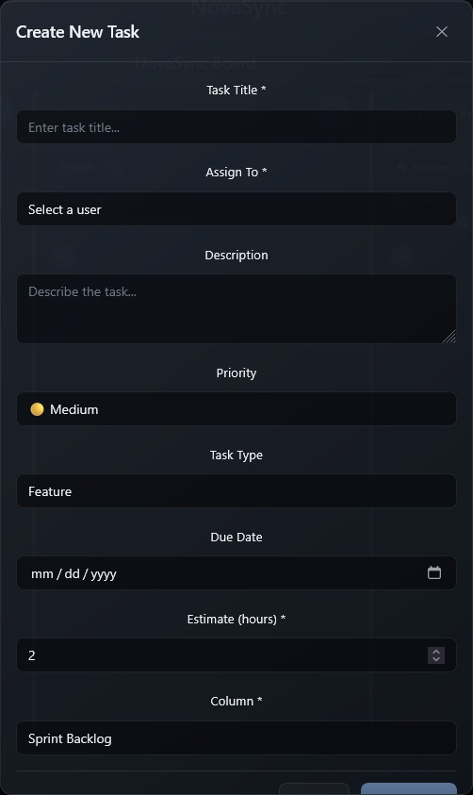
Figure 6.5: NovaSync – Create New Task

6.6 Edit Task
The Edit Task interface allows users to modify information belonging to an existing task.
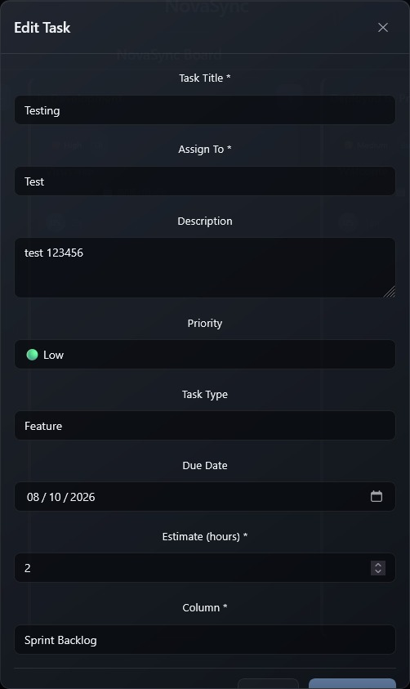
Figure 6.6: NovaSync – Edit Task

6.7 Delete Task
The Delete Task confirmation interface provides an additional confirmation step before permanently removing a task.
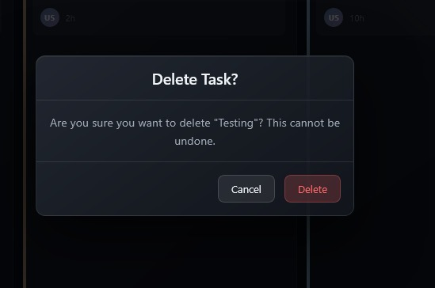
Figure 6.7: NovaSync – Delete Task Confirmation
6.8 Team Chat
The Team Chat interface provides a communication area for project members.
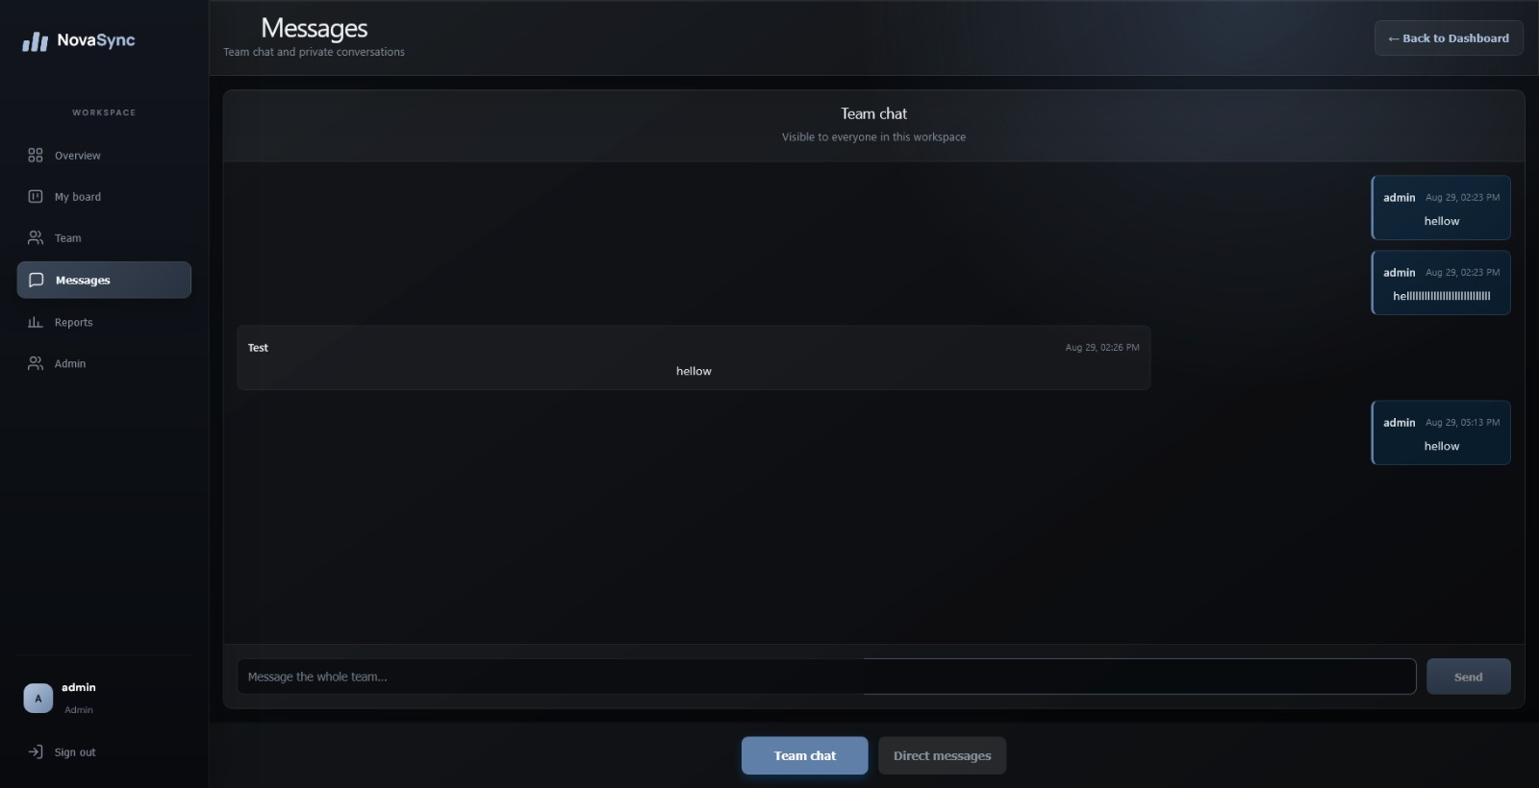
Figure 6.8: NovaSync – Team Chat
6.9 Direct Messages
The Direct Messages interface allows users to communicate privately with individual team members.
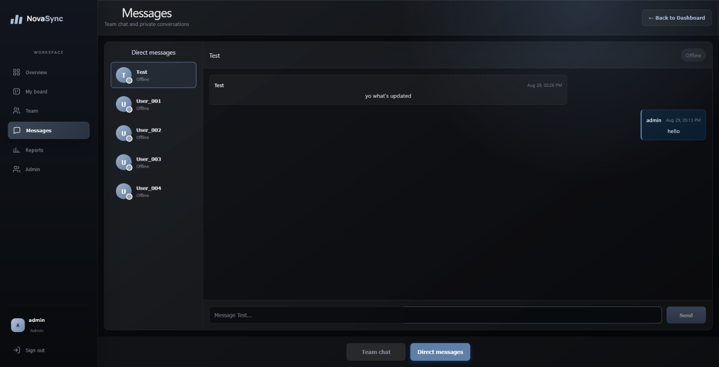
Figure 6.9: NovaSync – Direct Messages

Chapter 07. Backend Screenshots
7.1 Backend Server
This screenshot demonstrates the Node.js and Express backend server running successfully.
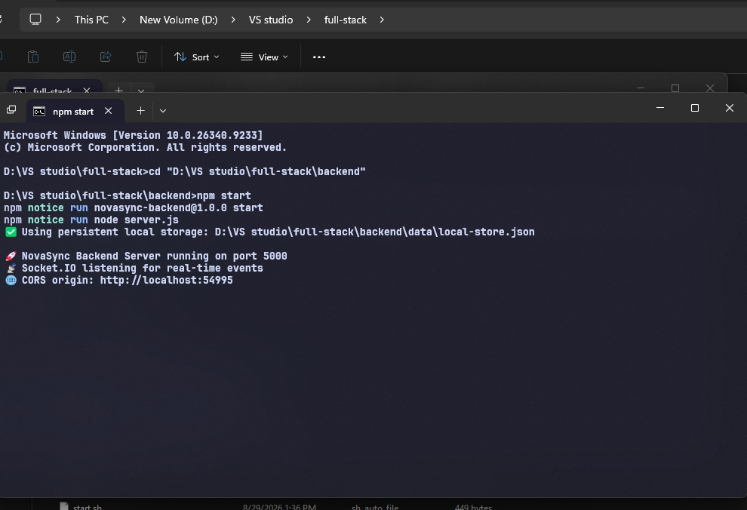
Figure 7.1: NovaSync – Backend Server
7.2 Backend Implementation
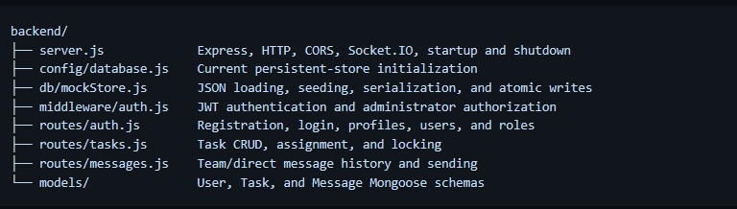
Figure 7.2: NovaSync – Backend Implementation

7.3 Backend Health Status
The Health Status endpoint is used to confirm that the NovaSync backend server is running correctly and is available to process client requests.
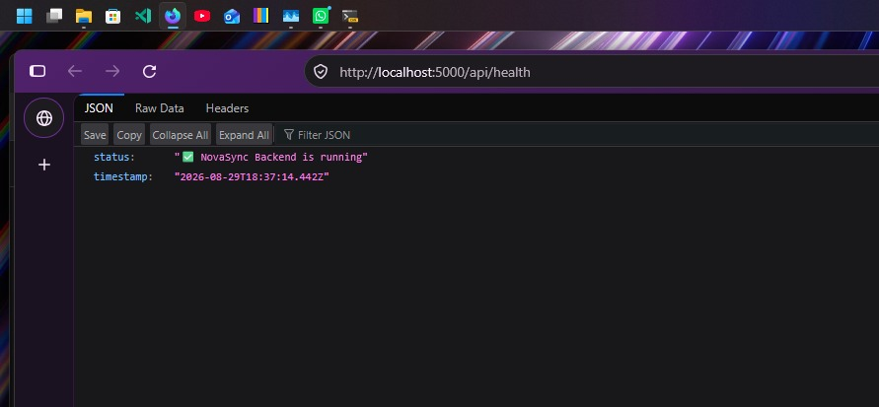
Figure 7.3: NovaSync – Backend Health Status

7.4 Authentication and Authorization
The backend includes authentication and authorization functionality to control access to protected resources. JWT-based authorization is used when accessing protected API endpoints.

Figure 7.4: NovaSync – Authentication and Authorization
7.5 User Logs
The User Logs provide supporting backend information related to user activity and application operations.
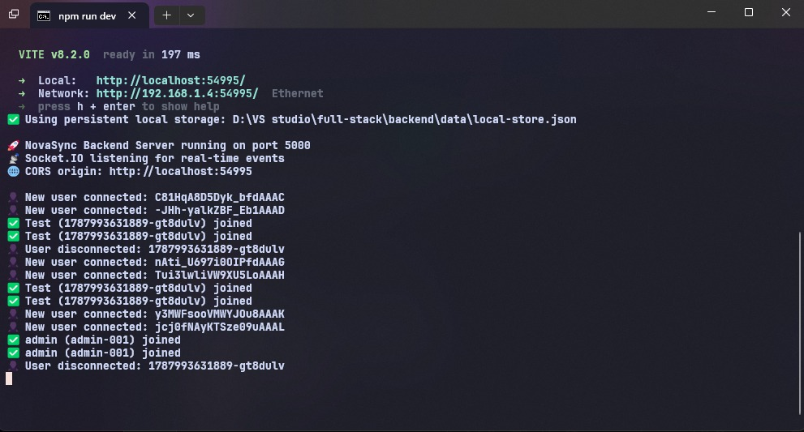
Figure 7.5: NovaSync – User Logs
7.6 Task Management Backend
The task management backend provides the API functionality required to retrieve and manage tasks. The backend supports the main CRUD operations required by the NovaSync task board.


Figure 7.6: NovaSync – Task Management API

Chapter 08. Frontend and Backend Integration
The main development objective of Assignment 02 was to connect the NovaSync React frontend with the Node.js and Express backend through working REST API endpoints.
The frontend uses Axios to send HTTP requests to the backend. Task operations performed through the user interface are processed by the corresponding backend API routes, allowing the frontend and server to exchange application data.
The integration provides the following workflow:
User Action ↓
React Frontend ↓
Axios Request ↓
Express REST API ↓
Backend Logic ↓
Mock Data ↓
API Response ↓
React State Update ↓
Updated Interface
This integration moves NovaSync beyond the static interface developed in Assignment 01 and establishes the client-server communication required for the working REST API milestone.

Chapter 09. Conclusion
Assignment 02 successfully extends NovaSync from a static frontend into a working client-server application by introducing a Node.js and Express backend and integrating REST APIs with the React frontend.
The implementation establishes the communication layer required for managing application data through backend endpoints. Authentication, task management, and messaging-related API structures have been incorporated into the project, while mock data is used to demonstrate the API functionality during this stage.
The separation between the React frontend and Express backend provides a clear and maintainable architecture for further development. This implementation creates the foundation for the next stages of the project, where persistent database storage, enhanced authentication, automated testing, real-time synchronization, containerization, and deployment can be integrated.
Overall, Assignment 02 represents the transition from the static front-end implementation to a functioning full-stack architecture in which the frontend and backend communicate through REST APIs.

